Restaurant SQL Project and Practice Question
Display all records from menu_items.
SELECT * FROM menu_items;
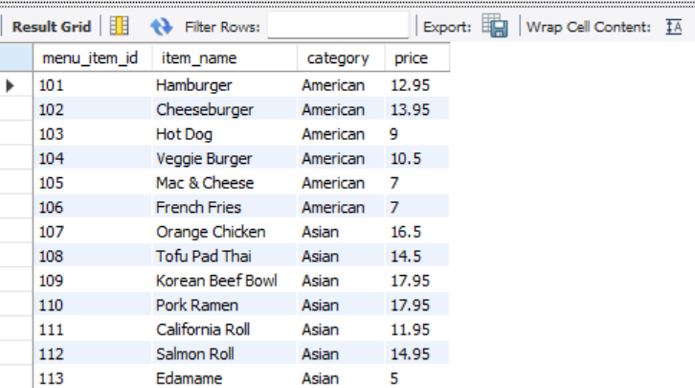

- Display all records from order_details.
SELECT * FROM order_details;
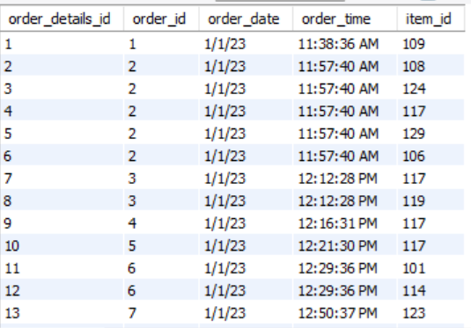

- Show only item_name and price from menu_items.
SELECT item_name,price
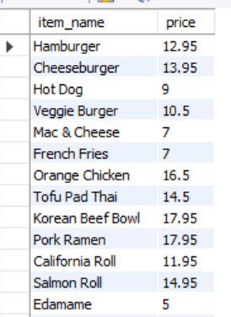
FROM menu_items;

Question. Find all menu items belonging to the American category.
SELECT *
FROM menu_items
WHERE category = 'American';
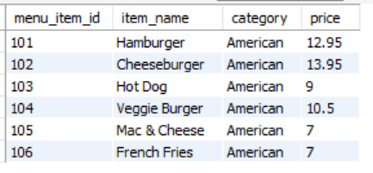
Question. Find menu items with a price greater than $15.
SELECT *
FROM menu_items
WHERE price > "15";
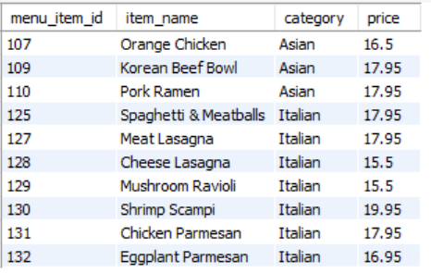

Question. List menu items ordered by price (highest to lowest).
SELECT *
FROM menu_items
ORDER BY price DESC;
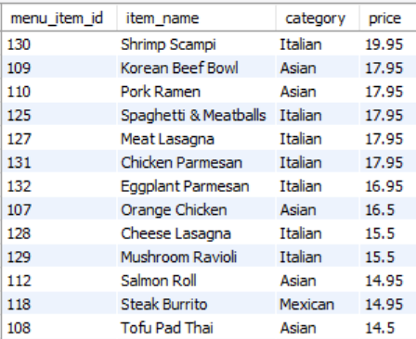

Question. List menu items alphabetically by item name.
SELECT *
FROM menu_items
ORDER BY item_name ASC;
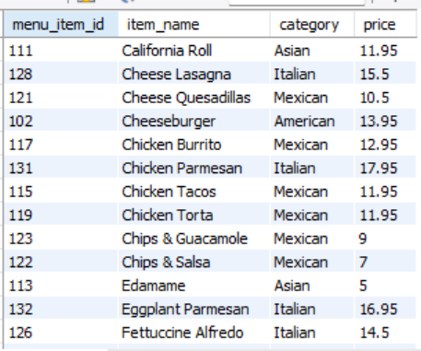

Question. Find menu items priced between $10 and $15.
SELECT *
FROM menu_items
WHERE price BETWEEN "10" AND "15";
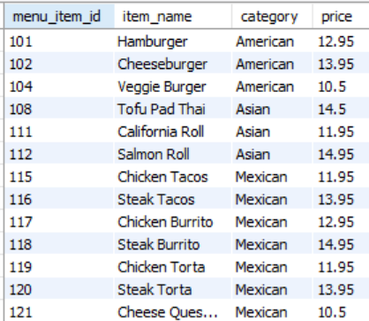
Question. Find all Italian dishes.
SELECT *
FROM menu_items
WHERE category = "Italian";
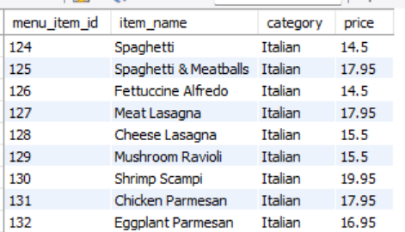
Question. Find menu items whose names contain the word Chicken.
SELECT *
FROM menu_items
WHERE item_name LIKE "%Chicken%";
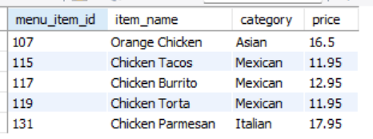

Question. Count the total number of menu items.
SELECT COUNT(*) AS total_menu_items
FROM menu_items;
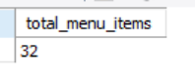

Question. Find the most expensive menu item.
SELECT *
FROM menu_items
ORDER BY price DESC
LIMIT 1;
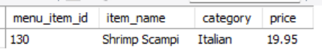

Question. Find the most expensive menu item.
SELECT *
FROM menu_items
ORDER BY price ASC
LIMIT 1;
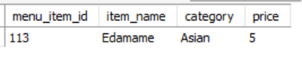

Question. Calculate the average menu item price.
SELECT round(Avg(price),2) AS Average_price
FROM menu_items ;
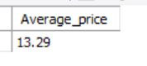

Question. Find the total value of all menu items.
SELECT round(SUM(price),2) AS total_menu_value
FROM menu_items;
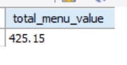

Question. Count how many menu items exist in each category.
SELECT category,COUNT(*) AS total_menu_category
FROM menu_items
GROUP BY Category
ORDER BY category DESC;

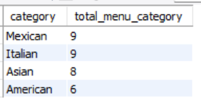

Question. Find the average price of items in each category.
SELECT category,round(AVG(Price),2) AS Categorywise_AVG_price
FROM menu_items
GROUP BY Category
ORDER BY category DESC;

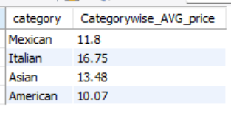

Question. Find the most expensive item in each category.
SELECT m.category,
m.item_name,
m.price
FROM menu_items m
WHERE m.price = (
SELECT MAX(price)
FROM menu_items
WHERE category = m.category
)
ORDER BY m.category;
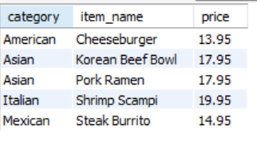

Question. Find the least expensive item in each category.
SELECT m.category,
m.item_name,
m.price
FROM menu_items m
WHERE m.price = (
SELECT MIN(price)
FROM menu_items
WHERE category = m.category
)
ORDER BY m.category;
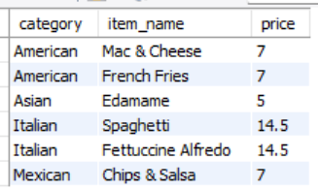

Question. Calculate the total menu value by category.
SELECT category,round(SUM(Price),2) AS total_menu_value
FROM menu_items
GROUP BY Category
ORDER BY total_menu_value DESC;
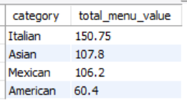

Question. Count the total number of rows in order_details.
SELECT COUNT(*) AS total_number_rows
FROM order_details;
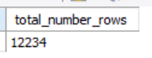

Question. Find the number of unique orders.
SELECT COUNT(DISTINCT order_id) AS unique_orders
FROM order_details;
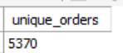

Question. Find the earliest order date.
SELECT MIN(order_date) AS earliest_order_date
FROM order_details;
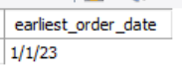
Question. Find the latest order date.
SELECT MAX(order_date) AS earliest_order_date
FROM order_details;
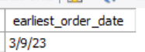

Question. Count orders placed on each date.
SELECT order_date,
COUNT(DISTINCT order_id) AS total_orders
FROM order_details
GROUP BY order_date
ORDER BY order_date;
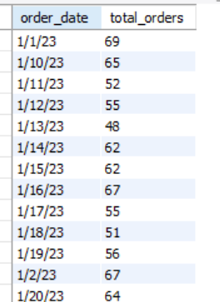

Question. Join both tables and display order details with item names.
SELECT *
FROM menu_items AS m
JOIN order_details AS od
ON od.item_id = m.menu_item_id;
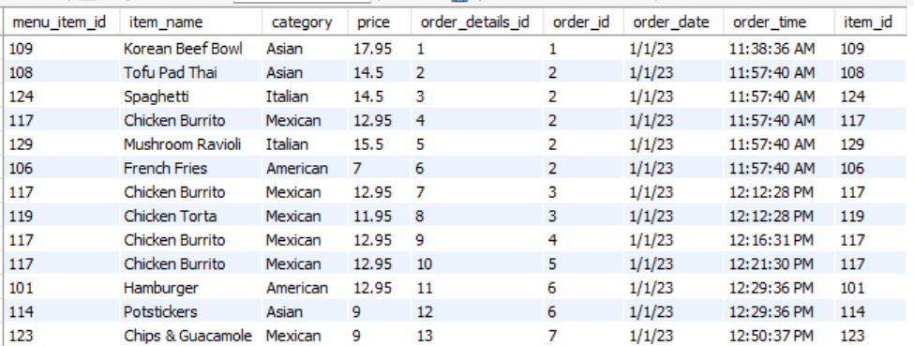

Question. Show all ordered items along with their category and price.
SELECT order_id,category,price
FROM order_details od
JOIN menu_items m
ON od.item_id = m.menu_item_id;
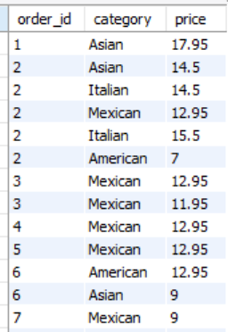

Question. Find how many times each menu item was ordered.
SELECT m.item_name,
COUNT(*) AS times_ordered
FROM order_details od
JOIN menu_items m
ON od.item_id = m.menu_item_id
GROUP BY m.item_name
ORDER BY times_ordered DESC;
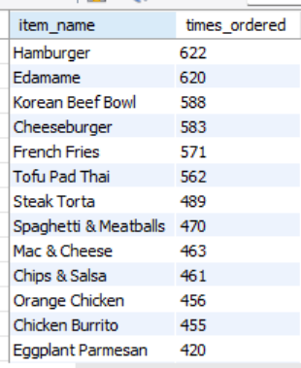

Question. Find the top 10 most ordered menu items.
SELECT m.item_name,
COUNT(*) AS times_ordered
FROM order_details od
JOIN menu_items m
ON od.item_id = m.menu_item_id
GROUP BY m.item_name
ORDER BY times_ordered DESC
LIMIT 10;
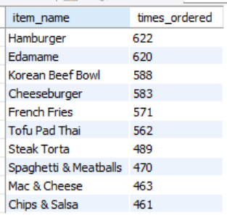

Question. Find the 10 least ordered menu items.
SELECT m.item_name,
COUNT(*) AS times_ordered
FROM order_details od
JOIN menu_items m
ON od.item_id = m.menu_item_id
GROUP BY m.item_name
ORDER BY times_ordered ASC
LIMIT 10;
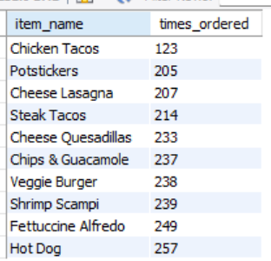

Question. Calculate total revenue generated.
SELECT round(SUM(m.price),2) AS total_revenue
FROM order_details od
JOIN menu_items m
ON od.item_id = m.menu_item_id;
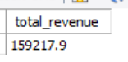

Question. Find revenue generated by each menu item.
SELECT m.menu_item_id,
m.item_name,
round(SUM(m.price),2) AS revenue
FROM order_details od
JOIN menu_items m
ON od.item_id = m.menu_item_id
GROUP BY m.menu_item_id, m.item_name
ORDER BY revenue DESC;
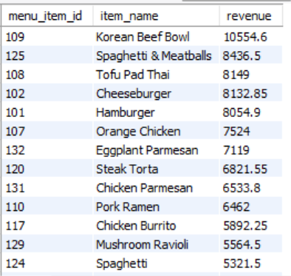

Question. Find revenue generated by each category.
SELECT m.category,
round(SUM(m.price),2) AS category_revenue
FROM order_details od
JOIN menu_items m
ON od.item_id = m.menu_item_id
GROUP BY m.category
ORDER BY category_revenue DESC;
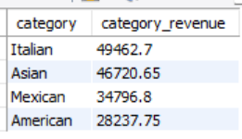

Question. Which category generated the highest revenue?
SELECT m.category,
round(SUM(m.price),2) AS category_revenue
FROM order_details od
JOIN menu_items m
ON od.item_id = m.menu_item_id
GROUP BY m.category
ORDER BY category_revenue DESC
LIMIT 1;
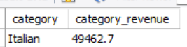

Question. Which menu item generated the highest revenue?
SELECT menu_items.menu_item_id,
menu_items.item_name,
round(SUM(menu_items.price),2) AS revenue
FROM order_details
JOIN menu_items
ON order_details.item_id = menu_items.menu_item_id
GROUP BY menu_items.menu_item_id,menu_items.item_name
ORDER BY revenue DESC
LIMIT 1;
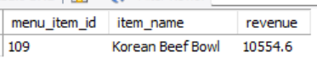

Question. Find the order containing the highest number of items.
SELECT order_id,
COUNT(*) AS total_items
FROM order_details
GROUP BY order_id
ORDER BY total_items DESC
LIMIT 1;
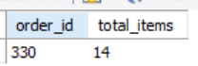

Question. Find the average number of items per order.
SELECT ROUND(
COUNT(*) * 1.0 / COUNT(DISTINCT order_id),
2
) AS avg_items_per_order
FROM order_details;
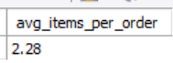

Question. Find orders with more than 5 items.
SELECT order_id,
COUNT(*) AS total_items
FROM order_details
GROUP BY order_id
HAVING COUNT(*) > 5
ORDER BY total_items DESC;
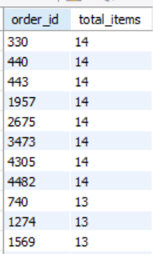

Question. Find the top 10 highest-value orders.
SELECT od.order_id,
ROUND(SUM(m.price), 2) AS order_value
FROM order_details od
JOIN menu_items m
ON od.item_id = m.menu_item_id
GROUP BY od.order_id
ORDER BY order_value DESC
LIMIT 10;

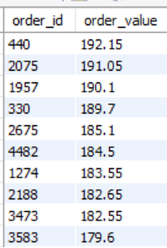

Question. Find the lowest-value order.
SELECT od.order_id,
ROUND(SUM(m.price), 2) AS order_value
FROM order_details od
JOIN menu_items m
ON od.item_id = m.menu_item_id
GROUP BY od.order_id
ORDER BY order_value ASC
LIMIT 1;
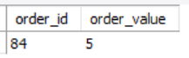

Question. Extract the hour from order_time.
SELECT order_id,hour(order_time)
From order_details;
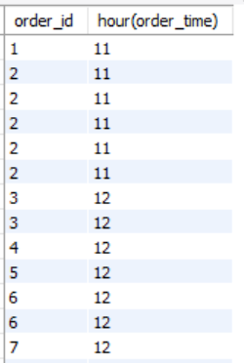

Question. Count orders by hour of day.
SELECT HOUR(order_time) AS order_hour,
COUNT(order_id) AS total_orders
FROM order_details
GROUP BY HOUR(order_time)
ORDER BY order_hour;
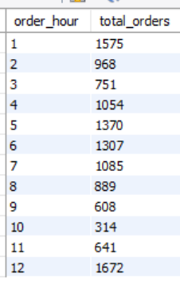

Question. Find the busiest hour.
SELECT HOUR(order_time) AS order_hour,
COUNT(order_id) AS total_orders
FROM order_details
GROUP BY HOUR(order_time)
ORDER BY total_orders DESC
LIMIT 1;
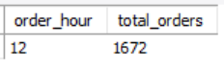

Question. Calculate revenue generated by each hour.
SELECT HOUR(od.order_time) AS order_hour,
ROUND(SUM(m.price), 2) AS revenue_per_hour
FROM order_details od
JOIN menu_items m
ON od.item_id = m.menu_item_id
GROUP BY HOUR(od.order_time)
ORDER BY order_hour;
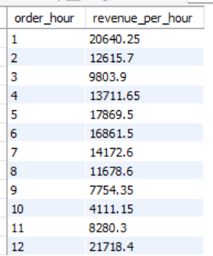

Question. Identify peak dining hours.
SELECT HOUR(order_time) AS dining_hour,
COUNT(DISTINCT order_id) AS total_orders
FROM order_details
GROUP BY HOUR(order_time)
ORDER BY total_orders DESC;
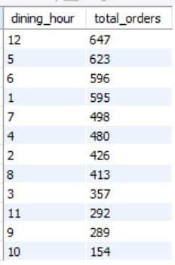

Question. Find Category-wise Revenue
SELECT m.category,
round(SUM(m.price),2) AS category_revenue
FROM order_details od
JOIN menu_items m
ON od.item_id = m.menu_item_id
GROUP BY m.category;
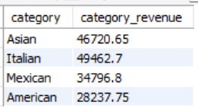

Question. Find Total Revenue
SELECT round(SUM(m.price),2)
FROM order_details od
JOIN menu_items m
ON od.item_id = m.menu_item_id;
